In a meeting, you want to discuss the Test Plan with the team members, but they are not interested - .

[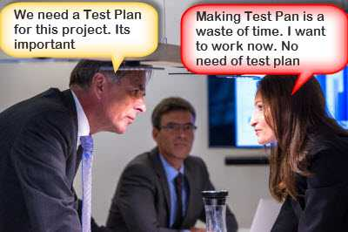](http://www.guru99.com/images/TestManagement/testmanagement_article_2_4_1.jpg)

In such case, what will you do? Select your answer as following figure

[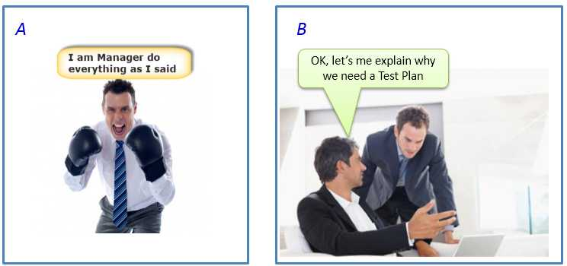](http://www.guru99.com/images/TestManagement/testmanagement_article_2_4_2.jpg)

A) I am Manager do everything as i said  
  
B) OK, let's me explain why we need a Test Plan

Incorrect  
  
As a Test Manager, you must explain them the importance of Test Plan rather than force the team to do what you want.

Correct  
  
As a Test Manager, you must explain them the importance of Test Plan rather than force the team to do what you want.

As a Test Manager, you must explain them the importance of Test Plan rather than force the team to do what you want.

Making Test Plan has multiple benefits

Test Plan helps us determine the effort needed to validate the quality of the application  under test

Help people outside the [test team](http://www.guru99.com/how-to-organize-a-test-team.html) such as developers, business managers, customersunderstand the details of testing.

Test Plan guides our thinking. It is like a rule book, which needs to be followed.

Important aspects like test estimation, test scope, test strategy are documented in Test Plan, so it can be reviewed by Management Team and re-used for other projects.

How to make a Test Plan

You already know that making a Test Plan is the most important task of [Test Management](http://www.guru99.com/test-management.html) Process. Follow the seven steps below to create a test plan

[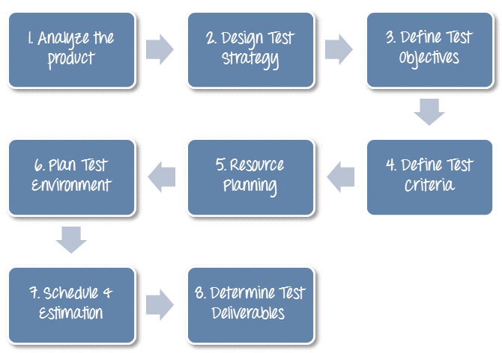](http://www.guru99.com/images/TestManagement/testmanagement_article_2_4_3.png)

Step 1) Analyze the product

How can you test a product without any information about it? The answer is Impossible. You must learn a product thoroughly before testing it.

The product under test is Guru99 banking website. You should research clients and the end users to know their needs and expectations from the application

Who will use the website?

What is it used for?

How will it work?

What are software/ hardware the product uses?

You can use the following approach to analyze the site

[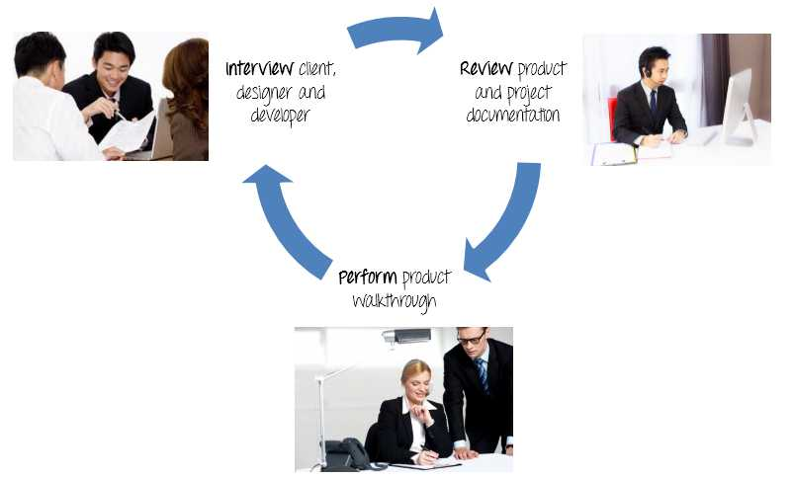](http://www.guru99.com/images/TestManagement/testmanagement_article_2_4_4.jpg)

Now let’s apply above knowledge to a real product: Analyze the banking website <http://demo.guru99.com/V4>.

[](http://www.guru99.com/images/TestManagement/Guru99TourFrame.gif)

You should take a look around this website and also review [product documentation](https://docs.google.com/document/d/1PZQZKt7hqS417QjYRMppPnTwfj8V54XUA7nZUnYvumE/edit?usp=sharing). Review of product documentation helps you to understand all the features of the website as well as how to use it. If you are unclear on any items, you might interview customer, developer, designer to get more information.

Step 2) Develop Test Strategy

Test Strategy is a critical step in making a Test Plan. A Test Strategy document, is a high level document, which is usually developed by Test Manager. This document defines:

The project’s testing objectives and the means to achieve them

Determines testing effort and costs

Back to your project, you need to develop Test Strategy for testing that banking website. You should follow steps below

[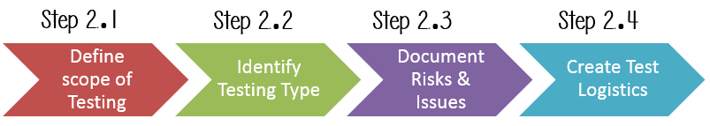](http://www.guru99.com/images/TestManagement/testmanagement_article_2_4_6.png)

Step 2.1) Define Scope of Testing

Before the start of any test activity, scope of the testing should be known. You must think hard about it.

The components of the system to be tested (hardware, software, middleware, etc.) are defined as "in scope"

The components of the system that will not be tested also need to be clearly defined as being "out of scope."

Defining the scope of your testing project is very important for all stakeholders. A precise scope helps you

Give everyone a confidence & accurate information of the testing you  are doing

All project members will have a clear understanding about what is tested and what is not

How do you determine scope your project?

To determine scope, you must –

Precise customer requirement

Project Budget

Product Specification

Skills & talent of your [test team](http://www.guru99.com/how-to-organize-a-test-team.html)

Now should clearly define the "in scope" and "out of scope" of the testing.

As the software requirement [specs](https://docs.google.com/document/d/1rPW5DV82VJT6vtA1VDSrfxaCBuAduxW0zb1yfTh_VMk/edit?pli=1#heading=h.ftgetk7f23qj), the project Guru99 Bank only focus on testing all the functions and external interface of website Guru99 Bank (in scope testing)

Non functional testing such as stress, performance or logical database currently will not be tested. (out of scope)

Problem Scenario

The customer wants you to test his API. But the project budget does not permit to do so. In such a case what will you do?

Well, in such case you need to convince the customer that API testing is extra work and will consume significant resources. Give him data supporting your facts. Tell him if API testing is included in-scope the budget will increase by XYZ amount.

The customer agrees and accordingly the new scopes, out of scope items are

In-scope items: Functional Testing, API Testing

Out of scope items: [Database testing](http://www.guru99.com/data-testing.html), hardware & any other external interfaces

Step 2.2) Identify Testing Type

A Testing Type is a standard test procedure that gives an expected test outcome.

Each testing type is formulated to identify a specific type of product bugs. But, all Testing Types are aimed at achieving one common goal “Early detection of all the defects before releasing the product to the customer”

The commonly used testing types are described as following figure

[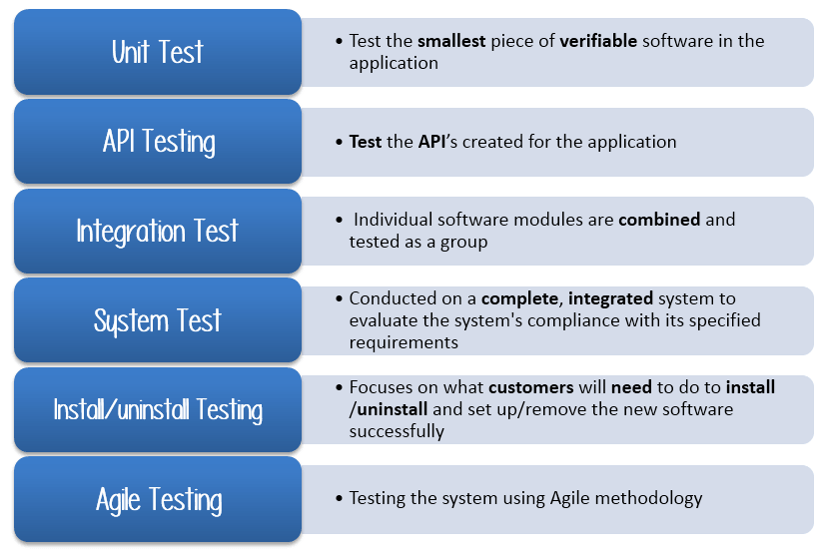](http://www.guru99.com/images/TestManagement/testmanagement_article_2_4_7.png)

There are tons of Testing Types for testing software product. Your team cannot have enough efforts to handle all kind of testing. As Test Manager, you must set priority of the Testing Types

Which Testing Types should be focused for web application testing?

Which Testing Types should be ignored for saving cost?

Now let's practice with your project. The product you want to test is a banking website.  
  
Which Testing Types should you focus in this case?  
  
Select All that Apply

A) Unit testing  
  
B) API Testing  
  
C) Integration Testing  
  
D) System Testing  
  
E) Install/Uninstall Testing  
  
F) [Agile testing](http://www.guru99.com/agile-scrum-extreme-testing.html)

We only select   
  
B) API Testing  
  
D) System Testing  
  
E) Integration Testing  
  
for Guru99 project

Step 2.3) Document Risk & Issues

Risk is future’s uncertain event with a probability of occurrence and a potential for loss. When the risk actually happens, it becomes the ‘issue’.

In the article [Risk Analysis and Solution](http://www.guru99.com/how-precaution-becomes-cure-risk-analysis-and-solutions-in-test-management.html), you have already learned about the ‘Risk’ analysis in detail and identified potential risks in the project.

In the Test Plan, you will document those risks

|  |  |
| --- | --- |
| Risk | Mitigation |
| Team member lack the required skills for website testing. | Plan training course to skill up your members |
| The project schedule is too tight; it's hard to complete this project on time | SetTest Priority for each of the test activity. |
| Test Manager has poor management skill | Plan leadership training for manager |
| A lack of cooperation negatively affects your employees' productivity | Encourage each team member in his task, and inspire them to greater efforts. |
| Wrong budget estimate and cost overruns | Establish the scope before beginning work, pay a lot of attention to project planning and constantly track and measure the progress |

Step 2.4) Create Test Logistics

 In Test Logistics, the Test Manager should answer the following questions:

Who will test?

When will the test occur?

Who will test?

You may not know exact names of the tester who will test, but the type of tester can be defined.

To select the right member for specified task, you have to consider if his skill is qualified for the task or not, also estimate the project budget. Selecting wrong member for the task may cause the project tofail or delay.

Person having the following skills is most ideal for performing software testing:

Ability to understand customers point of view

Strong desire for quality

Attentionto detail

Good cooperation

In your project, the member who will take in charge for the test execution is the tester. Base on the project budget, you can choose in-source or out-source member as the tester.

When will the test occur?

Test activities must be matched with associated development activities.

You will start to test when you have all required items shown in following figure

[](http://www.guru99.com/images/TestManagement/testmanagement_article_2_4_8.png)

Step 3) Define Test Objective

Test Objective is the overall goal and achievement of the test execution. The objective of the testing is finding as many software defects as possible; ensure that the software under test is bug free before release.

To define the test objectives, you should do 2 following steps

List all the software features (functionality, performance, GUI…) which may need to test.

Define the target or the goal of  the test based on  above features

Let’s apply these steps to find the test objective of your Guru99 Bank testing project

You can choose the ‘TOP-DOWN’ method to find the website’s features which may need to test. In this method, you break down the application under test to component and sub-component.

In the previous topic, you have already analyzed the requirement specs and walk through the website, so you can create a Mind-Map to find the website features as following

[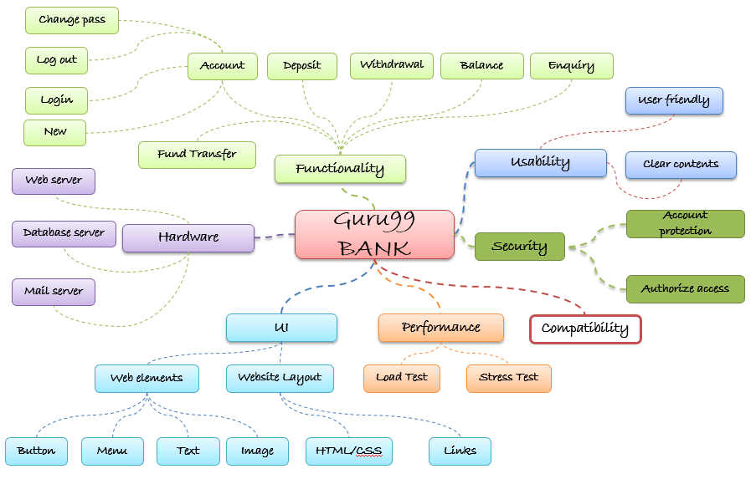](http://www.guru99.com/images/TestManagement/testmanagement_article_2_4_9.png)

This figure shows all the features which the Guru99 website may have.

Based on above features, you can define the Test Objective of the project Guru99 as following

Check that whether website Guru99 functionality(Account, Deposit…) is working as expected without any error or bugs in real business environment

Check that the external interface of the website such as UI is working as expected and & meet the customer need

Verify the usability of the website. Are those functionalities convenient for user or not?

Step 4) Define Test Criteria

Test Criteria is a standard or rule on which a test procedure or test judgment can be based. There’re 2 types of test criteria as following

Suspension Criteria

Specify the critical suspension criteria for a test. If the suspension criteria are met during testing, the active test cycle will be suspended until the criteria are resolved.

Example: If your team members report that there are 40% of test cases failed, you should suspend testing until the development team fixes all the failed cases.

[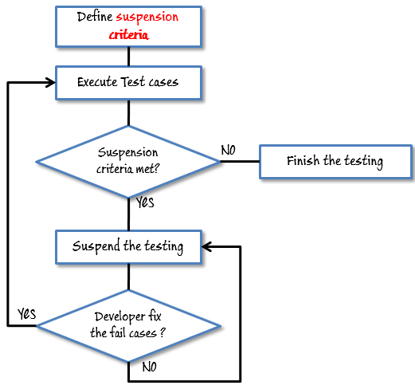](http://www.guru99.com/images/TestManagement/testmanagement_article_2_4_10.png)

Exit Criteria

It specifies the criteria that denote a successful completion of a test phase. The exit criteria are the targeted results of the test and are necessary before proceeding to the next phase of development. Example: 95% of all critical test cases must pass.

Some methods of defining exit criteria are by specifying a targeted run rate and pass rate.

Run rate is ratio between number test cases executed/total test cases of test specification. For example, the test specification has total 120TCs, but the tester only executed 100 TCsàthe run rate is 100/120 = 0.83 (83%)

Pass rate is ratio between numbers test cases passed / test cases executed. For example, in above 100 TCs executed, there’re 80TCs passedàthe pass rate is 80/100 = 0.8 (80%)

This data can be retrieved in Test Metric documents.

Run rate is mandatory to be 100% unless a clear reason is given.

Pass rate is dependent on project scope, but achieving high pass rate is a goal.

Example:Your Team has already done the test executions. They report the test result to you, and they want you to confirm the Exit Criteria.

[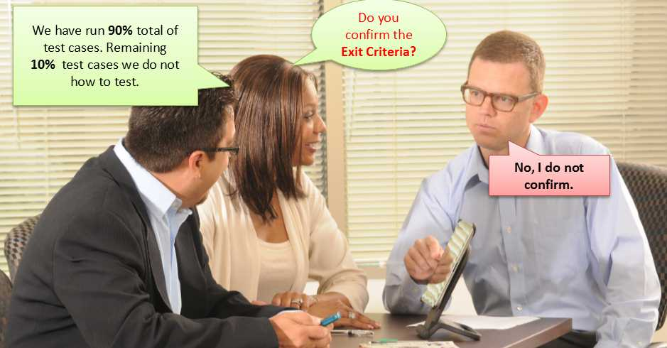](http://www.guru99.com/images/TestManagement/testmanagement_article_2_4_11.jpg)

In above case, the Run rate is mandatory is 100%, but the [test team](http://www.guru99.com/how-to-organize-a-test-team.html) only completed 90% of test cases. It means the Run rate is not satisfied, so do NOT confirm the Exit Criteria

Step 5) Resource Planning

Resource plan is a detailed summary of all types of resources required to complete project task. Resource could be human, equipment and materials needed to complete a project

The resource planning is important factor of the test planning because helps in determining the number of resources (employee, equipment…) to be used for the project. Therefore, the Test Manager can make the correct schedule & estimation for the project.

This section represents the recommended resources for your project.

Human Resource

The following table represents various members in your project team

|  |  |  |
| --- | --- | --- |
| No. | Member | Tasks |
| 1. | Test Manager | Managethe whole project  Define project directions  Acquire appropriate resources |
| 2. | Tester | Identifying and describing appropriate test techniques/tools/automation architecture  Verify and assess the Test Approach  Executethe tests, Log results, Report the defects.  Tester could be in-sourced or out-sourced members, base on the project budget  For the task which required low skill, I recommend you chooseoutsourced members to save project cost. |
| 3. | Developer in Test | Implementthe test cases, test program, test suite etc. |
| 4. | Test Administrator | Builds up and ensures test environment and assets are managed and maintained  SupportTester to use the test environment for test execution |
| 5. | [SQA](http://www.guru99.com/software-quality-assurance-test-audit-review-makes-your-life-easy.html) members | Take in charge of quality assurance  Check  to confirm whether the testing process is meeting specified requirements |

System Resource

For testing, a web application, you should plan the resources as following tables:

|  |  |  |
| --- | --- | --- |
| No. | Resources | Descriptions |
| 1. | Server | Install the web application under test  This includes a separate web server, database server, and application server if applicable |
| 2. | Test tool | The testing tool is to automate the testing, simulate the user operation, generate the test results  There are tons of test tools you can use for this project such as [Selenium](http://www.guru99.com/selenium-tutorial.html), [QTP](http://www.guru99.com/quick-test-professional-qtp-tutorial.html)…etc. |
| 3. | Network | You need a Network include LAN and Internet to simulate the real business and user environment |
| 4. | Computer | The PC which users often use to connect the web server |

Step 6) Plan Test Environment

What is the Test Environment

A testing environment is a setup of software and hardware on which the testing team is going to execute test cases. The test environment consists of real business and user environment, as well as physical environments, such as server, front end running environment.

How to setup the Test Environment

Back to your project, how do you set up test environment for this banking website?

To finish this task, you need a strong cooperation between [Test Team](http://www.guru99.com/how-to-organize-a-test-team.html) and Development Team

[](http://www.guru99.com/images/TestManagement/testmanagement_article_2_4_12.png)

You should ask the developer some questions to understand the web application under testclearly. Here’re some recommended questions. Of course, you can ask the other questions if you need.

What is the maximum user connection which this website can handle at the same time?

What are hardware/software requirements to install this website?

Does the user's computer need any particular setting to browse the website?

Following figure describes the test environment of the banking website [www.demo.guru99.com/V4](http://www.demo.guru99.com/V4)

[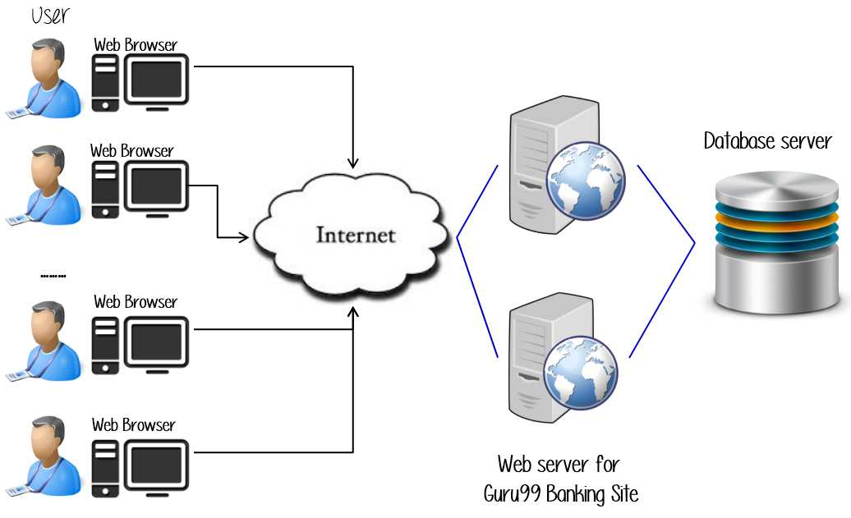](http://www.guru99.com/images/TestManagement/testmanagement_article_2_4_13.jpg)

Step 7) Schedule & Estimation

In the article [Test estimation](http://www.guru99.com/an-expert-view-on-test-estimation.html), you already used some techniques to estimate the effort to complete the project. Now you should include that estimation as well as the schedule to the Test Planning

In the Test Estimation phase, suppose you break out the whole project into small tasks and add the estimation for each task as below

|  |  |  |
| --- | --- | --- |
| Task | Members | Estimate effort |
| Create the test specification | Test Designer | 170 man-hour |
| Perform Test Execution | Tester, Test Administrator | 80 man-hour |
| Test Report | Tester | 10 man-hour |
| Test Delivery |  | 20 man-hour |
| Total |  | 280 man-hour |

Then you create the schedule to complete these tasks.

Making schedule is a common term in project management. By creating a solid schedule in the Test Planning, the Test Manager can use it as tool for monitoring the project progress, control the cost overruns.

To create the project schedule, the Test Manager needs several types of input as below:

Employee and project deadline: The working days, the project deadline, resource availability are the factors which affected to the schedule

Project estimation:  Base on the estimation, the Test Manager knows how long it takes to complete the project. So he can make the appropriate project schedule

Project Risk : Understanding the risk helps Test Manager add enough extra time to the project schedule to deal with the risks

Let’s practice with an example:

Suppose the boss wants to complete the project Guru99 in one month, you already estimated the effort for each tasks in Test Estimation. You can create the schedule as below

[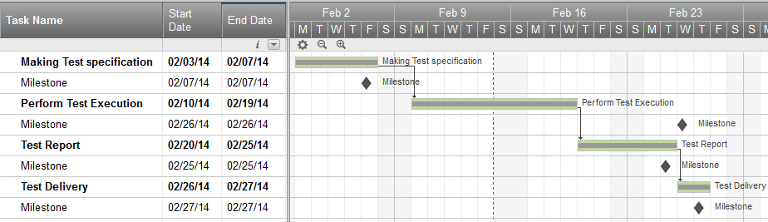](http://www.guru99.com/images/TestManagement/testmanagement_article_2_4_14.png)

Step 8) Test Deliverables

Test Deliverables is a list of all the documents, tools and other components that has to be developed and maintained in support of the testing effort.

There are different test deliverables at every phase of the software development lifecycle.

[](http://www.guru99.com/images/TestManagement/testmanagement_article_2_4_15.png)

Test deliverables are provided before testing phase.

Test plans document.

Test cases documents

Test Design specifications.

Test deliverables are provided during the testing

Test Scripts

Simulators.

Test Data

Test Trace-ability Matrix

Error logs and execution logs.

Test deliverables are provided after the testing cycles is over.

Test Results/reports

Defect Report

Installation/ Test procedures guidelines

Release notes